Staff details

Marcus

- Aged 35
- Fully qualified with certificates to prove competence
- Has been working in the holistic therapy field for many years in a mobile capacity
- Treats clients of all ages
- Will undertake any treatment on the list

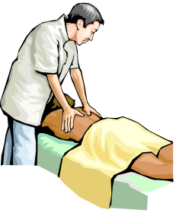

Sharona

- Aged 55
- Fully qualified with certificates to prove competence
- Just started working in the holistic therapy field following early retirement as a staff nurse in a geriatric environment
- Very good with elderly clients but treats patients of all ages
- Will undertake any treatment on the list, and excellent at Indian Head massage

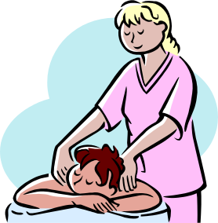

Note: the pictures have been taken from ClipArt files © Microsoft – you will need to add your own pictures of the staff involved.

